EM425 Assignment #8

Problem Statements

1. Use MATLAB’s built-in function integral3 to evaluate the integral below.



Write a function that uses a generalization of the mean value algorithm for Monte Carlo integration, where ; N is the number of sample points, and, for this integral, the volume of integral bounds is 8. Create a convergence plot to show that the relative error in your Monte Carlo solution (relative to the solution from integral3) is proportional to .

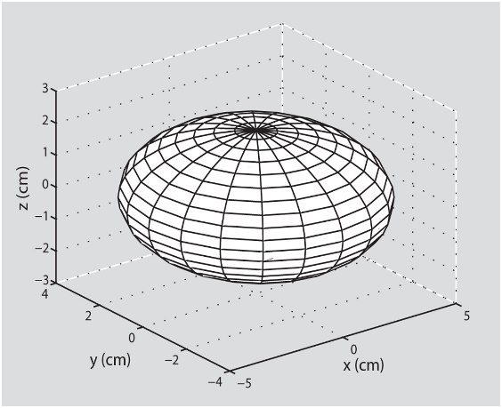2. (Based on 9.42) In imaging and treatment of breast cancers, an ellipsoidal shape may be used to represent certain tumors so that changes in their surface areas may be quantified and monitored during treatment. The surface area of an ellipsoid is given by:



where    and  are the major dimensions of the ellipsoid along the  respectively. For   and  calculate the surface area of this ellipsoidal tumor using MATLAB built-in functions.

3. (Based on 10.15) Write a user-defined MATLAB function to solve a first-order system of initial value ODEs. The signature should be [t,y] = odesEULER(F,a,b,N,yINI) where F is a handle to a function that defines the system of ODEs, a and b are the starting and end points in t and yINI is a vector of initial conditions. Use this function to solve the following IVP:



The exact solution is: . Solve the system once for N = 100 and again for N = 1000. Check that your solution exhibits convergence of order 1 using relative error in the 2-norm.

4. (Based on 10.2) Consider the following first-order IVP:



Solve by hand (pencil-paper-calculator) with the classical fourth-order Runge-Kutta method using h = 0.5. The analytical solution of the ODE is . Calculate the error between the true solution and the analytic solution at t = 0.5, 1.0, and 1.5 sec.

Problem #4 continued

5. (Based on 10.26) Consider the cylindrical water tank that is shown in the figure. The tank is being filled at the top, and water flows out of the tank through a pipe that is connected at the bottom. The rate of change of the height,  of the water is given by the equation below:

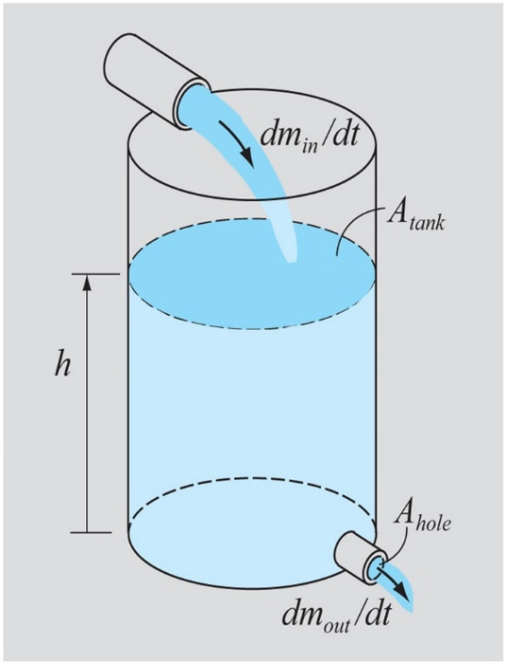 

For the given tank, 

Also  1000 kg/m3, and g = 9.81 m/s2. Determine and plot the height of the water as a function of time for  seconds if, at  

1. Use the odesEULER function you created for problem #3.
2. Create a user defined MATLAB function with signature [t,y] = odesCRK4(F,a,b,N,yINI) that implements the classical fourth order Runge-Kutta method. Use this function to solve the problem. [**note:** you are free to adapt any of the code presented during lectures to help solving this problem.]

For both methods, use N = 1000. In addition to the plot, output the value of h(150) for each method.

Take some time to consider both the given initial value problem, your solution and its implication on the design of this tank. What happens when you change the parameters Atank, Apipe, K1, K2 and C? Do those changes make sense? Assuming there are limits on acceptable values of  how does that impact your choice of design parameters such as Atank and Apipe relative to K1, K2 and C? Write a short discussion (one or two paragraphs, with supporting plots) to present your findings.

6. (Based on 10.31) A small rocket having an initial weight of 3000 lb (including 2400 lb of fuel), and initially at rest, is launched vertically upward. The rocket burns fuel at a constant rate of 80 lb/s, which provides a constant thrust, T, of 8000 lb. The instantaneous weight of the rocket is  lb. The drag force, D, experienced by the rocket is given by lb, where y is the distance in ft, and g = 32.2 ft/s2. Using Newton’s law, the equation of motion for the rocket is given by:



Determine and plot the position, velocity, and acceleration of the rocket (three sets of axes in one figure; use MATLAB’s subplot function) as a function of time from  when the rocket starts moving upward from rest, until  Also, output the distance and velocity at t = 3 sec.

Use the user-defined function you created for problem #5 to solve this equation using the classical fourth-order Runge-Kutta method with N = 1000. You may need to adapt the function slightly if you did not initially implement the function to solve systems of equations.

Take some time to consider the given initial value problem and its solution.

1. Explain the governing equation and each of its terms.
2. How is the solution different if you do not consider the weight change due to burning of fuel?
3. What happens if the drag force is eliminated?
4. What if the leading term in the drag force is cut in half? How does this change the shape of the acceleration curve and does this make sense?

Write a short discussion (one or two paragraphs, with supporting plots) to present your findings.

**Solutions:**

